Practical No.9
Develop application to download image/video from server or upload image/video to server using MTOM techniques
MTOM (Message Transmission Optimization Mechanism)
- MTOM (Message Transmission Optimization Mechanism) is a technique used in web services to optimize the transmission of binary data, such as images, documents, and other large files, over SOAP (Simple Object Access Protocol) messages. It is primarily designed to address the inefficiencies associated with Base64 encoding, which is commonly used to transmit binary data within SOAP messages.
Step1: Create a Project with Name CCWS_MTOM_Server
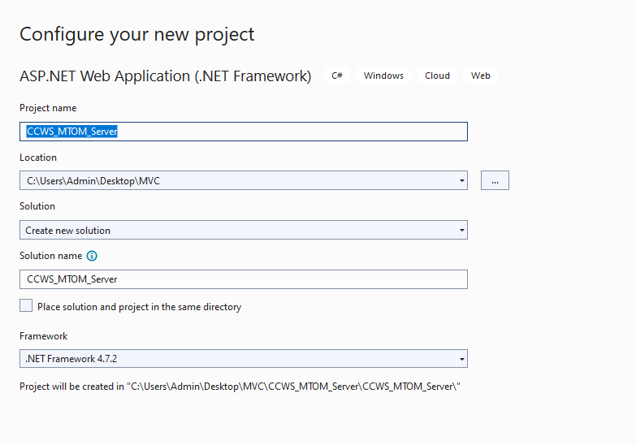
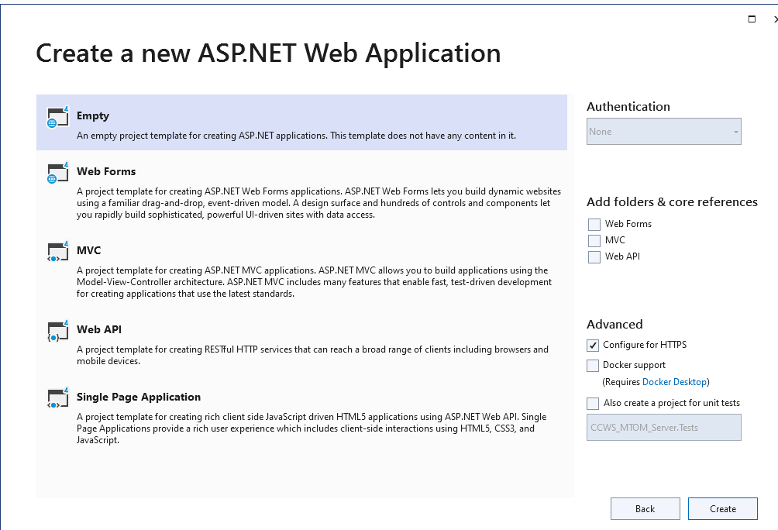
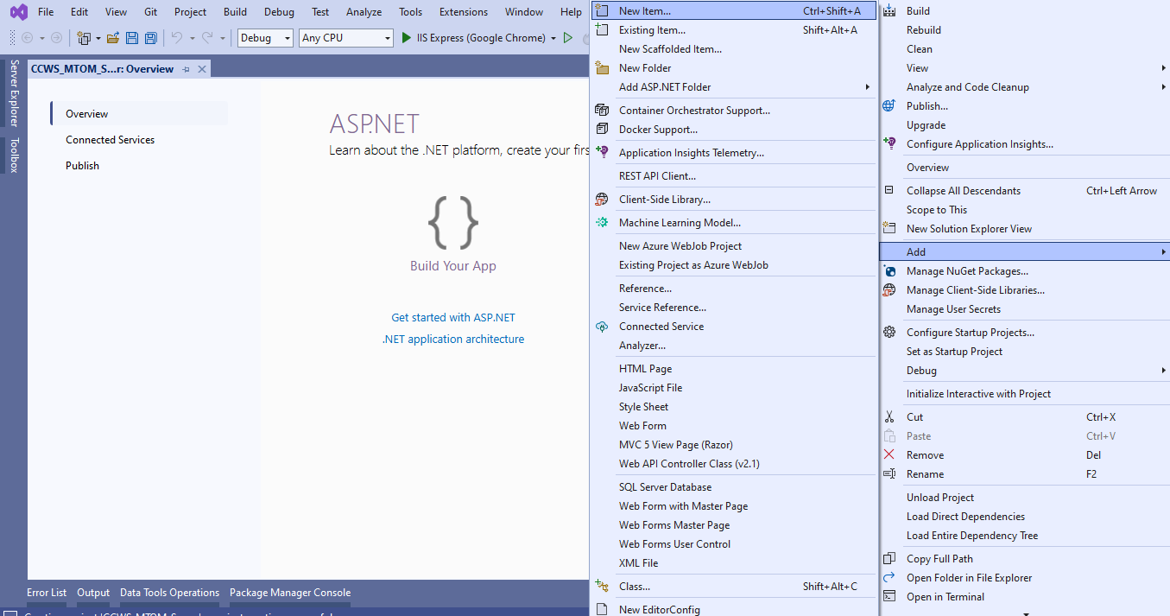
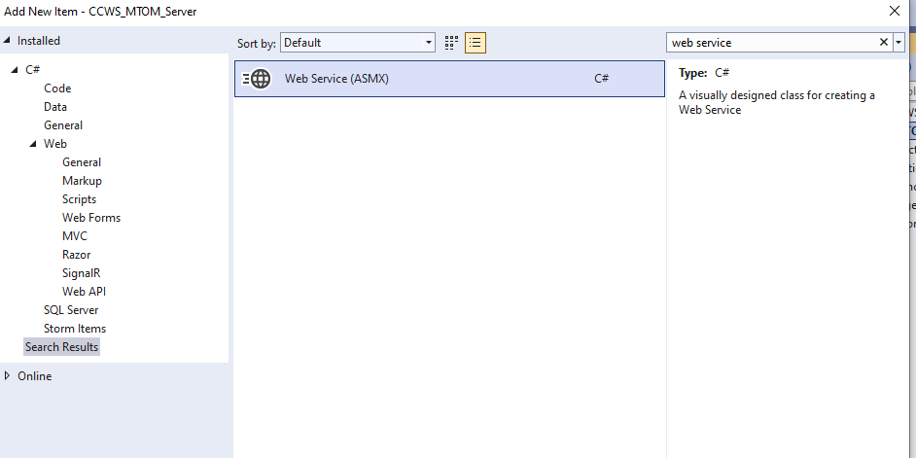
Change name to DownloadImageWS.asmx
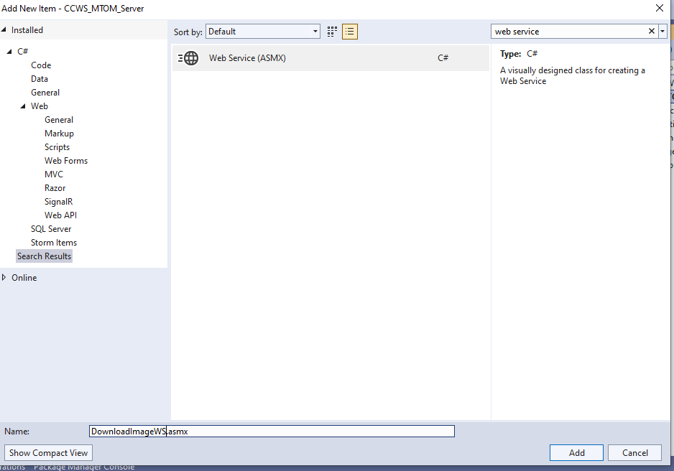
using System;
using System.Collections.Generic;
using System.ComponentModel;
using System.Linq;
using System.Web;
using System.Web.Services;

namespace CCWS_MTOM_Server
{
/// <summary>
/// Summary description for DownloadImageWS
/// </summary>
[WebService(Namespace = "http://tempuri.org/")]
[WebServiceBinding(ConformsTo = WsiProfiles.BasicProfile1_1)]
[System.ComponentModel.ToolboxItem(false)]
// To allow this Web Service to be called from script, using ASP.NET AJAX, uncomment the following line.
// [System.Web.Script.Services.ScriptService]
public class DownloadImageWS : System.Web.Services.WebService
{

[WebMethod]
public string HelloWorld()
{
return "Hello World";
}
[WebMethod, Description("Get Image")]
public byte[] GetImageFile(String filename)
{
if (System.IO.File.Exists(Server.MapPath("~/Images/") + filename))
{
return System.IO.File.ReadAllBytes(Server.MapPath("~/Images/") + filename);
}
else
{
return new byte[] { 0 };
}
}
}
}

Step2 : Create a handler file for MTOM.
Goto Solution Explorer -> Right Click and Add GenericHandler
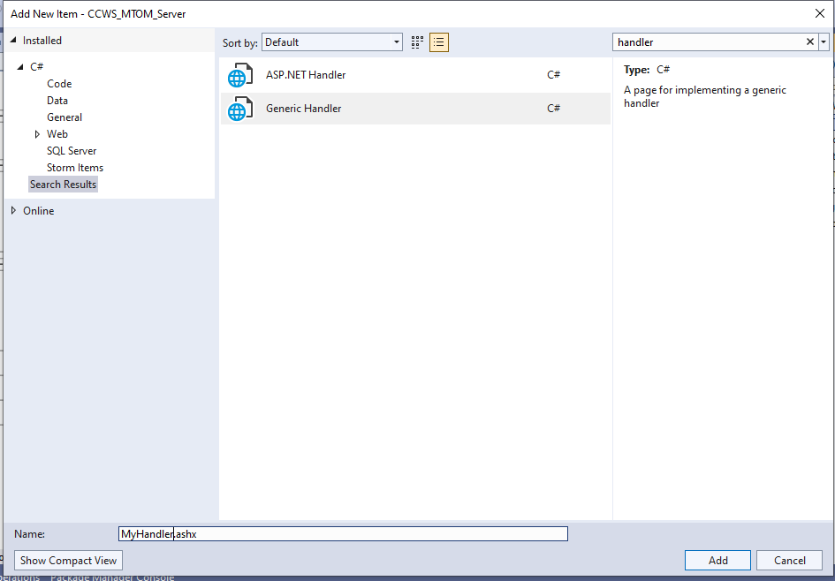
using System;
using System.Collections.Generic;
using System.Linq;
using System.Web;

namespace CCWS_MTOM_Server
{
/// <summary>
/// Summary description for MyHandler
/// </summary>
public class MyHandler : IHttpHandler
{

public void ProcessRequest(HttpContext context)
{
DownloadImageWS ws = new DownloadImageWS();
byte[] binImage = ws.GetImageFile(context.Request["filename"]);
if (binImage.Length == 1)
{

}
else
{
context.Response.ContentType = "image/jpeg";
context.Response.BinaryWrite(binImage);
}
}

public bool IsReusable
{
get
{
return false;
}
}
}
}

Step3 : Create a Webform1.aspx as follows
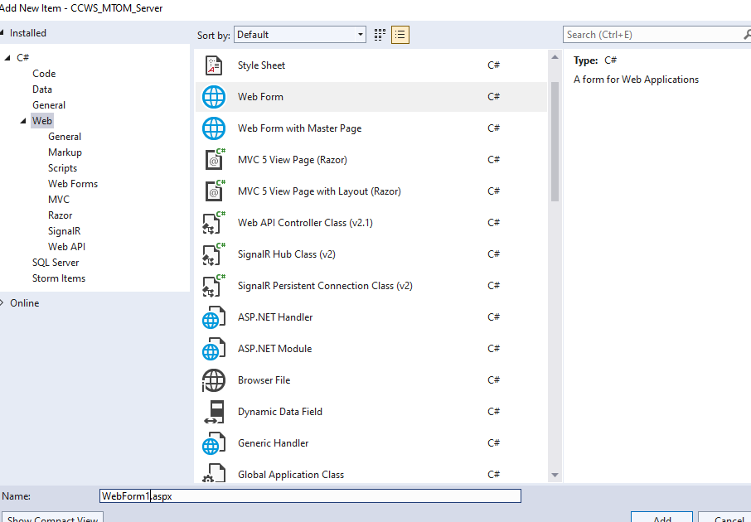
Webform1.aspx

<%@ Page Language="C#" AutoEventWireup="true" CodeBehind="WebForm1.aspx.cs" Inherits="CCWS_MTOM_Server.WebForm1" %>

<!DOCTYPE html>

<html xmlns="http://www.w3.org/1999/xhtml">
<head runat="server">
<title></title>
</head>
<body>
<form id="form1" runat="server">
<center>
<asp:Label ID="lbl1" runat="server" Font-Bold="True" Font-Size="X-Large" Text="Jilani 6024"></asp:Label>
<br />
<br />
<asp:Label ID="lbl2" runat="server" Text="Enter The Image Name to downlod : "></asp:Label>
&nbsp;<asp:TextBox ID="txt1" runat="server" BorderStyle="Ridge"></asp:TextBox>
<br />
<br />
<asp:Button ID="btn1" runat="server" BorderStyle="Ridge" OnClick="btn1_Click" Text="Click Here to Download" />
<br />
<br />
<asp:Image ID="Image1" runat="server" />
</center>
</form>
</body>
</html>

Webform1.aspx.cs

using System;
using System.Collections.Generic;
using System.Linq;
using System.Web;
using System.Web.UI;
using System.Web.UI.WebControls;

namespace CCWS_MTOM_Server
{
public partial class WebForm1 : System.Web.UI.Page
{
protected void Page_Load(object sender, EventArgs e)
{

}

protected void btn1_Click(object sender, EventArgs e)
{
Image1.ImageUrl = "~/MyHandler.ashx?filename=" + txt1.Text;
Response.Write("Downloading of Image is done");
}
}
}

Create a folder with name images and copy and paste the image as follows.
